**Contents Vs Children:**

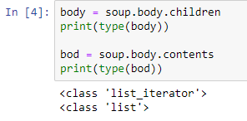

**Comments:**

1. In a large tree, children method is preferable.

**Decendants:**

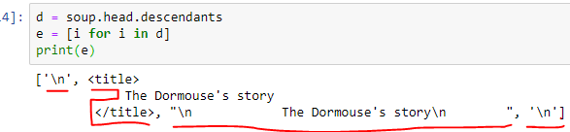

**Comments:**

1. Head has four decendants i.e. children and children of children and so on.

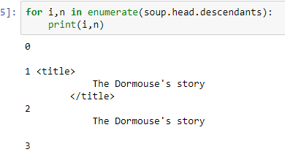

**Comments:**

1. It is now clear that head has four descendants using enumerate method.
2. .name returns the name of the tag.

**Parent:**

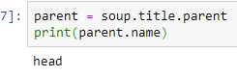

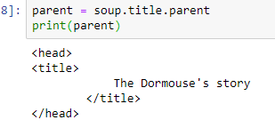

**Comments:**

1. .name returns the name of the tag.
2. .parent returns the parent tag with its all sub tags.

**Parents:**

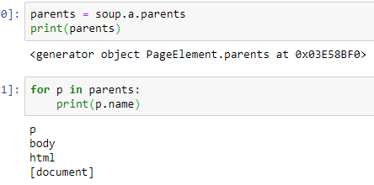

**Comments:**

1. .parents returns a list (generator) type.
2. Parsing through parents method, a 🡪 p 🡪 body 🡪 html 🡪 document or bs4.